Shammah Thao

EEE 117L Network Analysis Lab

Lab 1 DC Measurements

Professor Cottle

**Introduction:**

This lab utilizes several digital and analog instruments that can be used to measure resistance, voltage and current. The instruments I used were a digital multimeter and an Analog discovery. Using the digital multimeter I was able to find the ohms of the resistors as well as the voltage running through them. Using the analog discovery tools, I was able to find the voltage across multiple resistors as well as put power through them. The three circuits, required to be constructed by the lab assignment, deal with voltage, resistance, and current calculations.

**Procedure:**

Part 1: Resistance Measurements

* For this part of the lab, we needed to measure the resistance of each resistor and compare it to the specified value.

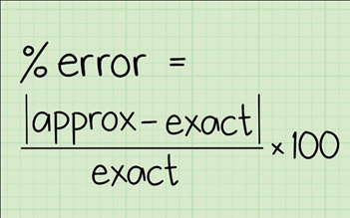

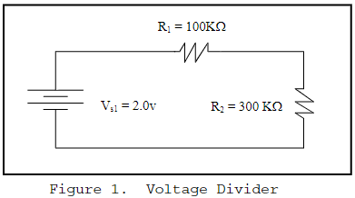

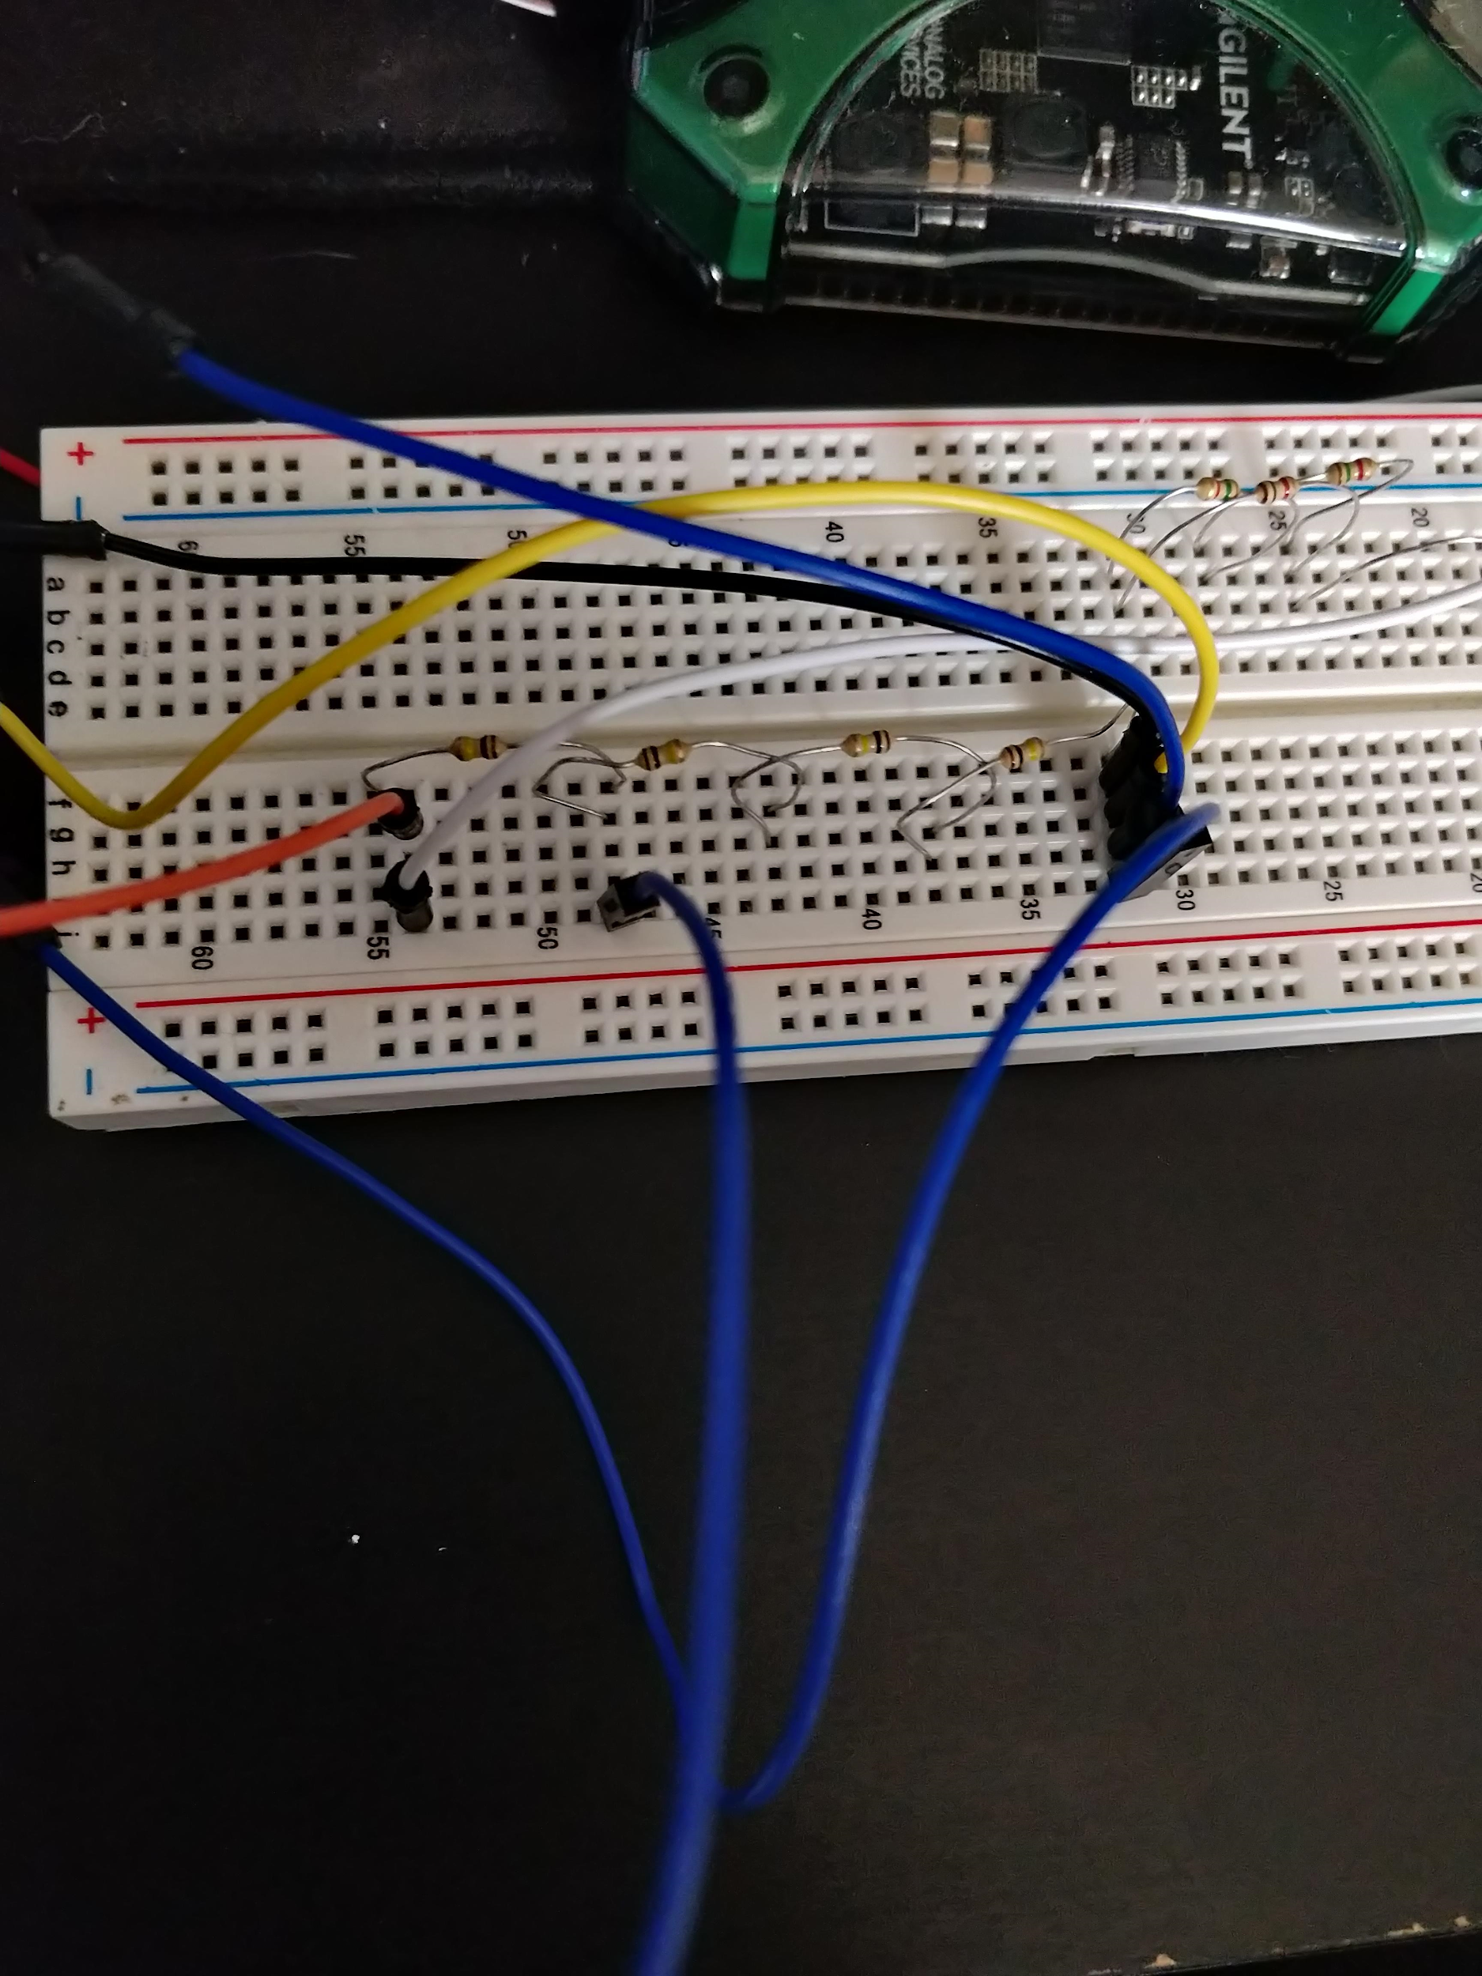

Figure 1: Here I used 3 100k resistors in series with 1 100k resistor to match the diagram above.

|  |  |  |  |
| --- | --- | --- | --- |
| R1 | 100KΩ | 100.27KΩ | 0.27% |
| R2 | 300KΩ | 295.14KΩ | 1.65% |
| R3 | 2KΩ | 1.99KΩ | 0.50% |
| R4 | 1KΩ | 0.99KΩ | 1.01% |
| R5 | 3KΩ | 3.04KΩ | 1.32% |

Part 2: Voltage Measurements

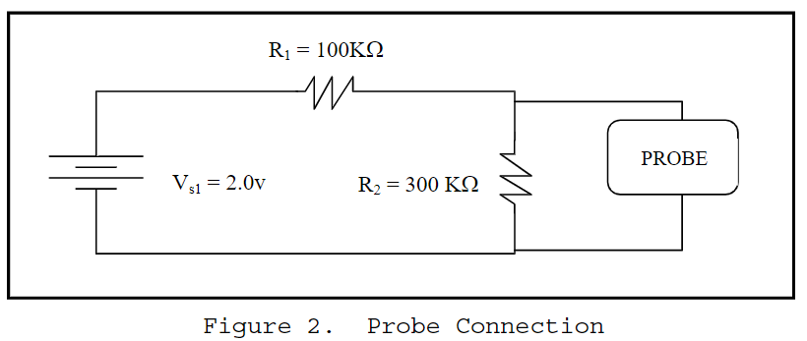

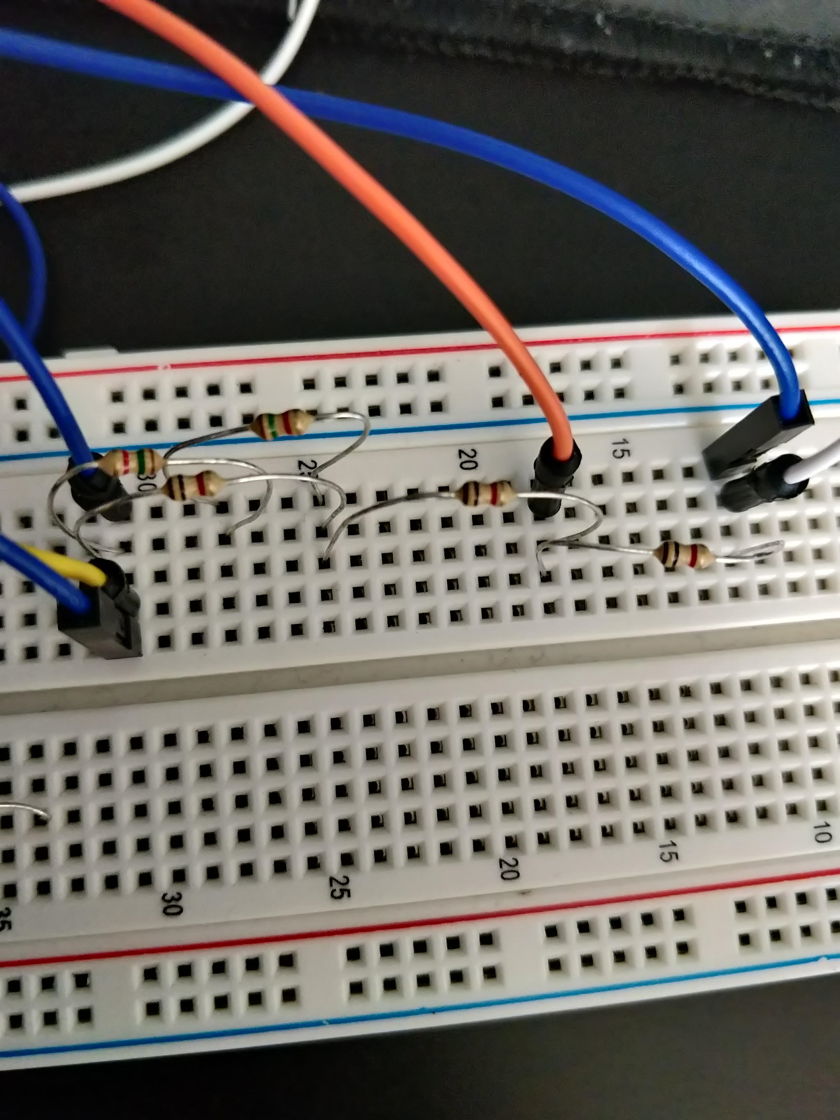

Figure 2: Here I constructed the Circuit above using an X1 (1000kΩ) probe in parallel with the 300k resistor.

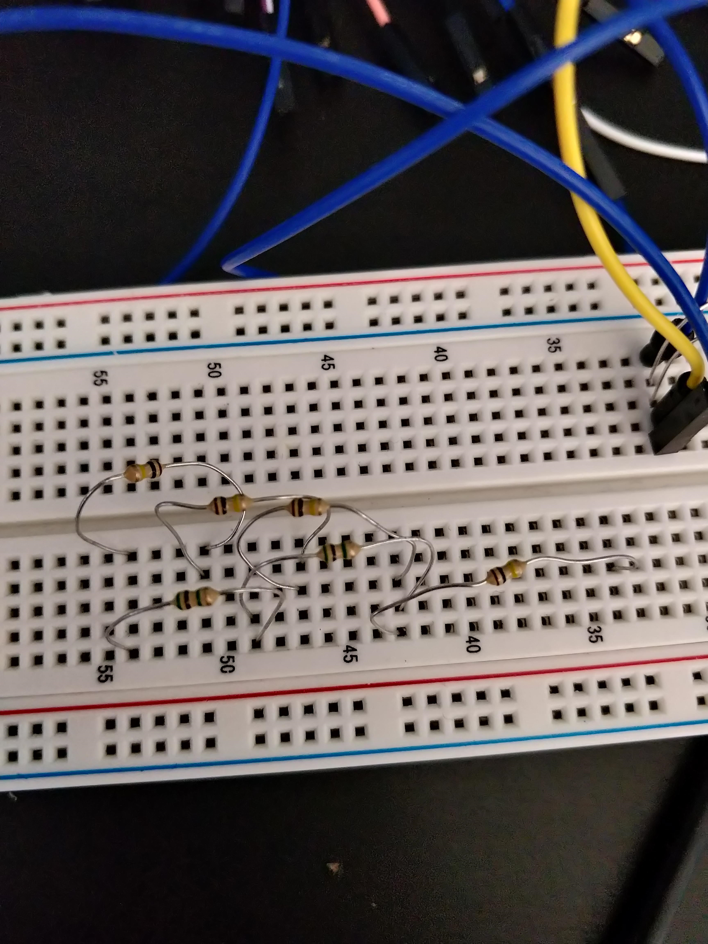

Figure 3: Here I constructed the Circuit above using an X10 (x2-5MΩ) probe in parallel with the 300k resistor.

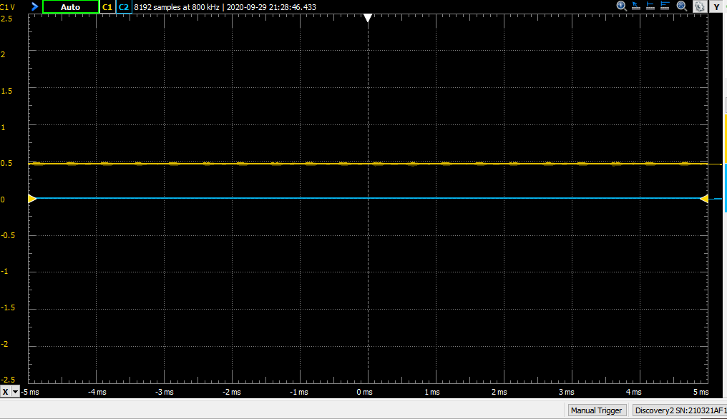

Figure 4: Here we recorded the resistance between the 2 volt supply and R1

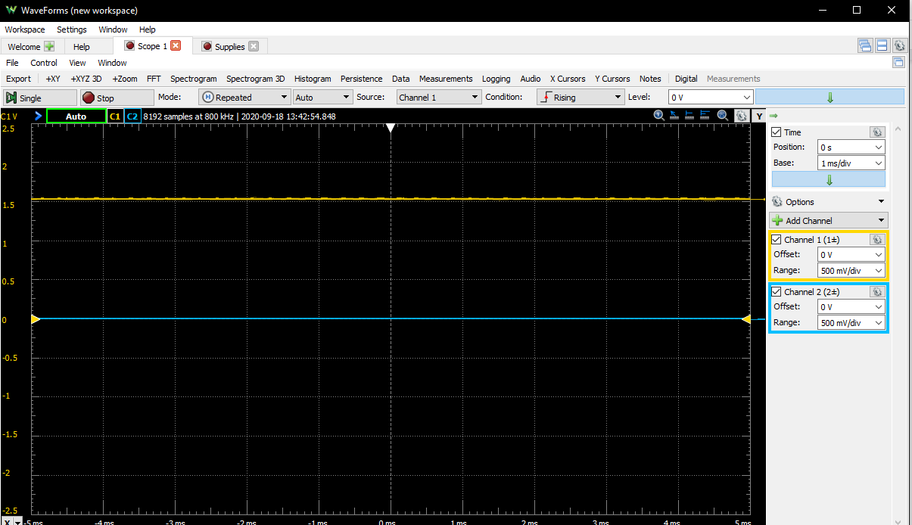

Figure 5: Here we recorded the resistance between the 2 volt supply and R2

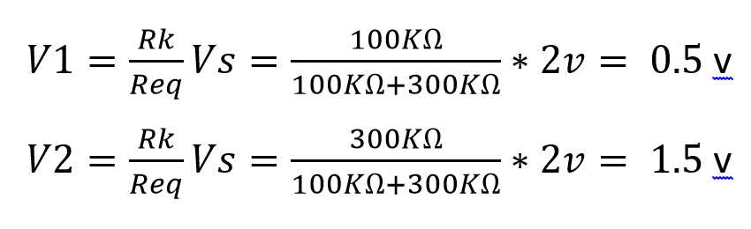

1. Unloaded Voltage Readings

|  |  |  |  |
| --- | --- | --- | --- |
| Unloaded Measurement | Theoretical Value | Actual Value | Percent Error |
| VS1 | 2V | 1.99V | 0.50% |
| R1 | 0.5V | 0.49V | 2.00% |
| R2 | 1.5V | 1.55V | 3.33% |

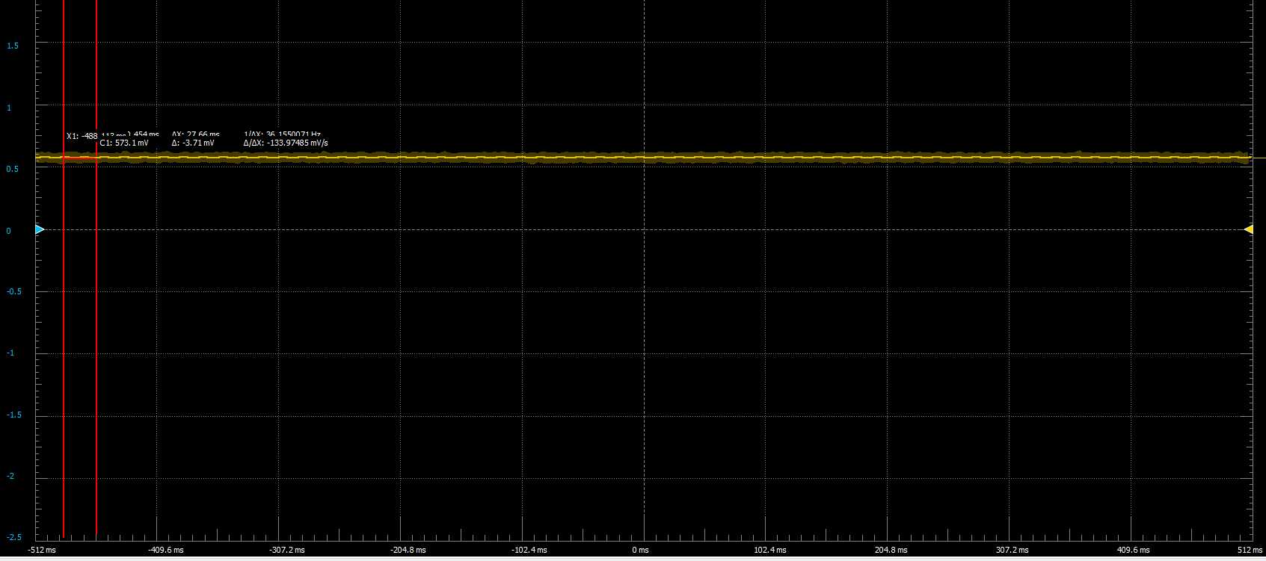

Figure 6: Here we recorded the resistance between the 2 volt supply and R1 in series with R2 in parallel with a 1m resistor (as the probe).

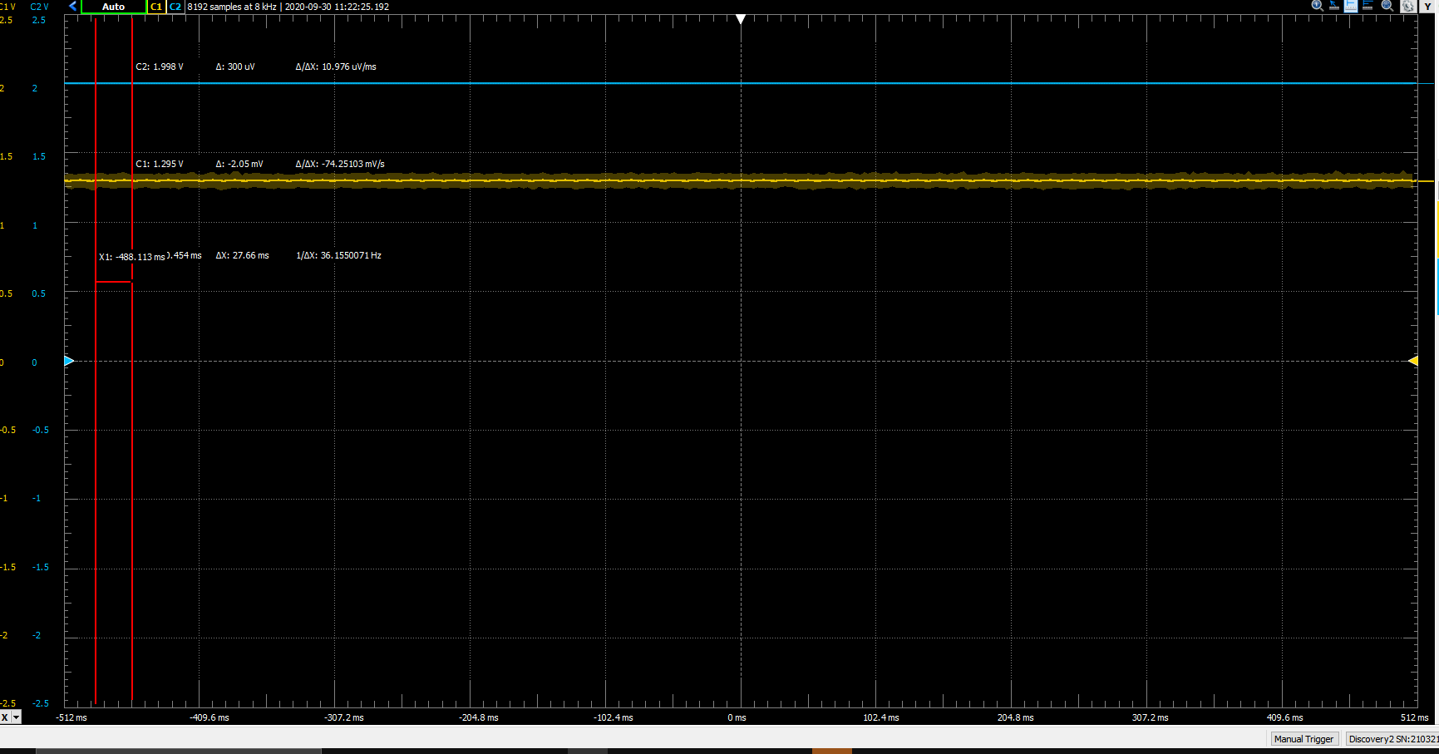

Figure 7: Here we recorded the resistance between the 2 volt supply and R2 in parallel with a 1m resistor (as the probe) as well as R1 in series.

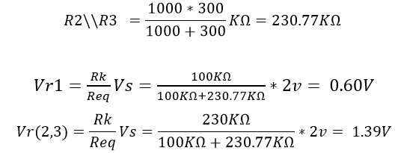

1. Loaded Voltage Reading

|  |  |  |  |
| --- | --- | --- | --- |
|  |  |  |  |
| Loaded Measurement | Theoretical Value | Actual Value | Percent Error |
| VS1 | 2V | 1.99V | 0.50% |
| R1 | 0.60V | 0.57V | 5.26% |
| R2 | 1.39V | 1.30V | 6.92% |

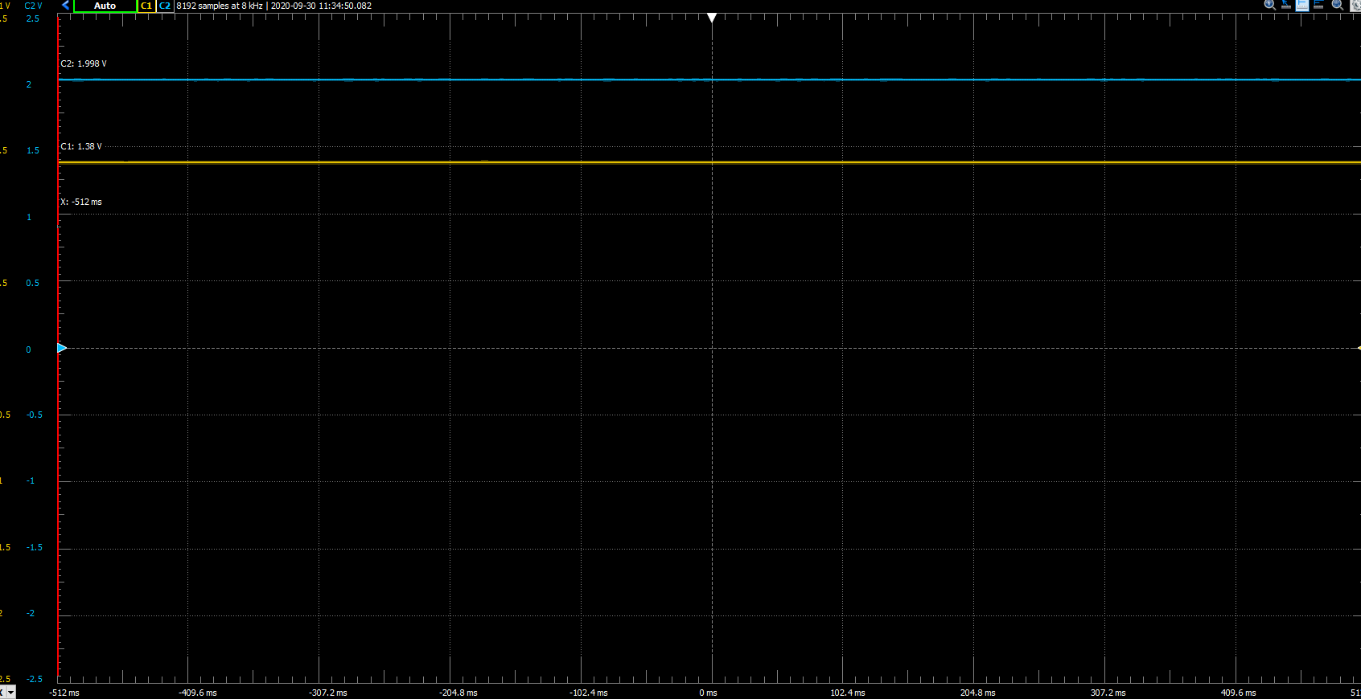

Figure 8: Here we recorded the resistance between the 2 volt supply and R1 in series with R2 that is in parallel with a 10m resistor (as the probe).

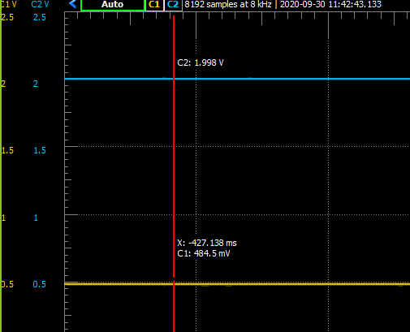

Figure 9: Here we recorded the resistance between the 2 volt supply and R2 in parallel with a 10m resistor (as the probe) as well as R1 in series.

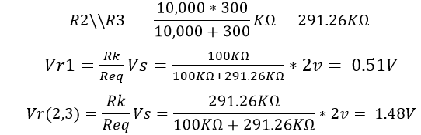

C.Loaded Voltage Reading(x10 Probe)

|  |  |  |  |
| --- | --- | --- | --- |
| Loaded Measurement | Theoretical Value | Actual Value | Percent Error |
| VS1 | 2V | 1.99V | 0.50% |
| R1 | 0.51V | 0.48 | 6.25% |
| R2 | 1.48V | 1.38 | 7.24% |

Part 3: Current Measurements

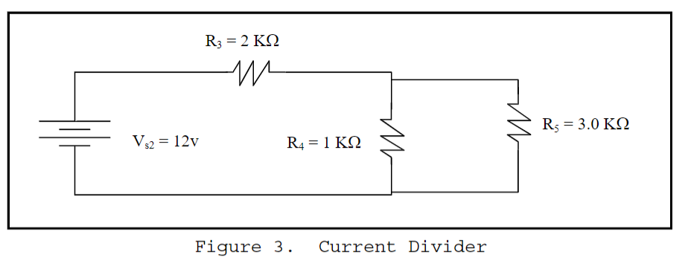



Figure 10: Here we constructed the diagram provided above. We used R3 and R4 in series and R4 and R5 in parallel.

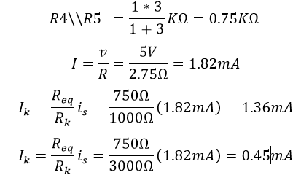

|  |  |  |  |
| --- | --- | --- | --- |
| Current Measurement | Theoretical Value | Actual Value | Percent Error |
| IR3 | 1.82mA | 1.82mA | 0% |
| IR4 | 1.36mA | 1.36mA | 0% |
| IR5 | 0.45mA | 0.45mA | 0% |

**Conclusion:**

The overall lessons that we learned from this lab consist of working with circuit analysis, building circuits, and working with Kirchhoff’s Current and Voltage Laws. In terms of circuit analysis, we had to analyze that the circuits were voltage and current dividers, respectively. I found that building circuits was the most challenging portion of the lab because translating a schematic to a physical circuit was difficult. Another aspect of this lab that was very beneficial was learning how to use the laboratory equipment using the digital multimeter, ammeter, and the analogy discovery. Thorough hand calculations and measurements using the previously listed measurements helped us to perform a proper analysis of our data.

**Discussion Topics:**

**1. How close to the color code values were the resistors and were they within the specified tolerances. (refer to color code chart )**

They were very close from 0.2 to 2.5 percent error margin.

**2. Were Kirchhoff’s laws verified? /3. Were current and voltage division verified?**

During the lab we used Kirchhoff’s Voltage and Current Laws to calculate the voltage and current in the given current divider/voltage divider circuits. Kirchhoff’s current/voltage laws were verified in the case of lab because the measured values matched the calculated values.

**5. Did the measured input voltage V4 match that shown on the AD2 display?**

Yes, it did.